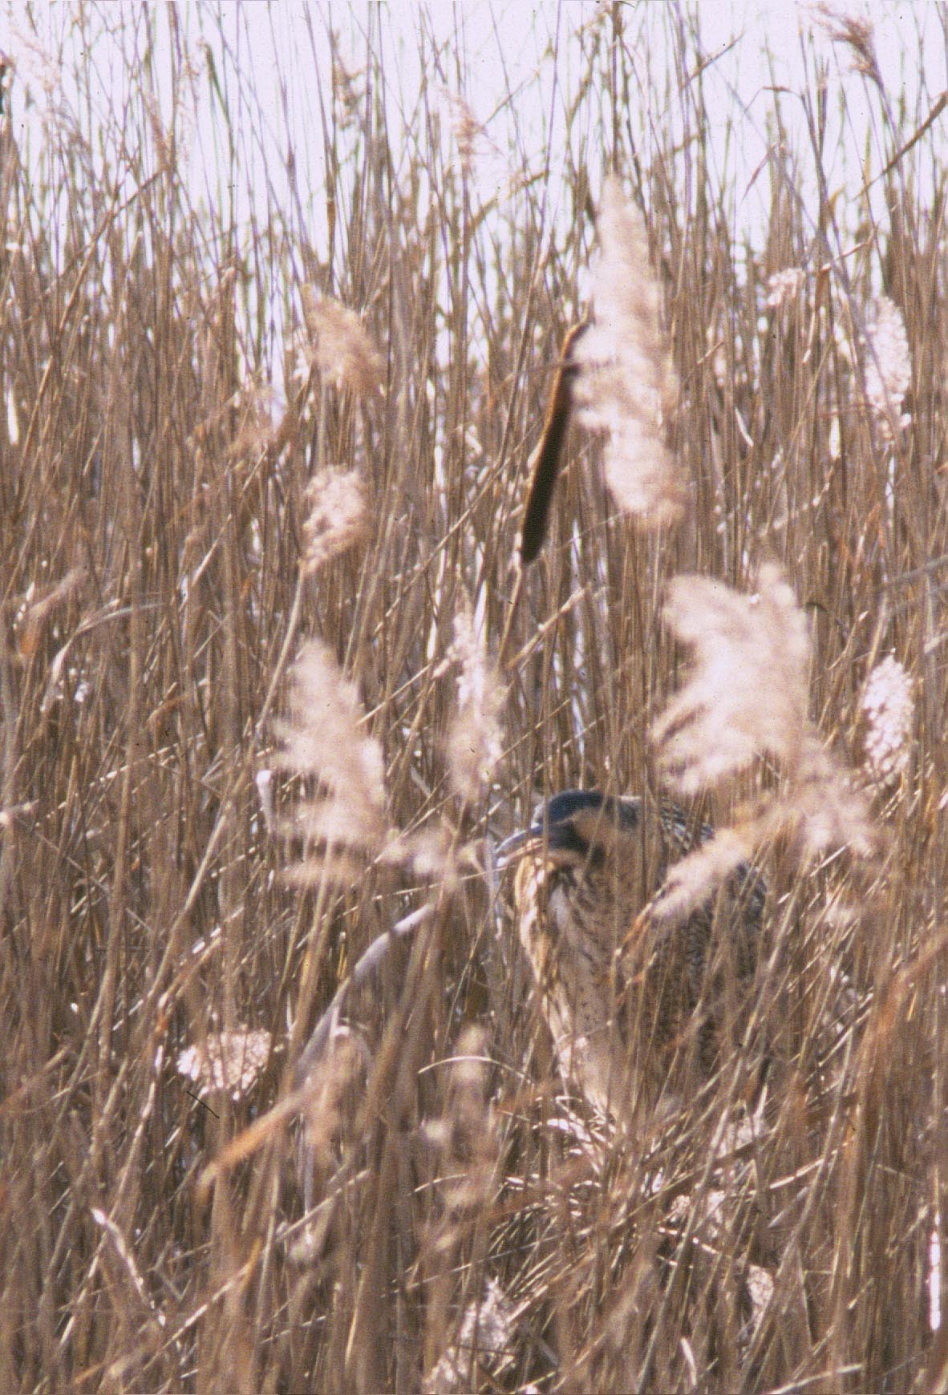

Reedbeds and Bittern © Mike Waite

“Sweet are the sounds that mingle from afar,
Heard by calm lakes, as peeps the folding star,
Where the duck dabbles 'mid the rustling sedge,
And feeding pike starts from the water's edge,
Or the swan stirs the reeds, his neck and bill
Wetting, that drip upon the water still;
And heron, as resounds the trodden shore,
Shoots upward, darting his long neck before.”
(William Wordsworth 'An Evening’s Walk')

- Aims
- To ensure the protection and optimal management of reedbeds in Greater London.
- To demonstrate the value of reedbeds and to promote their creation in the urban environment.

- Introduction
Reedbeds are areas of shallow water dominated by a tall wetland grass called common reed (Phragmites australis). The UK’s largest native grass, common reed is a particularly conspicuous species, with cane-like stems that last throughout the winter. Reedbeds in London occur at the margins of all kinds of waterbodies and alongside several other habitats, including wet woodlands and willow-dominated scrub.
Historically, the Thames Estuary and basin would have supported extensive reedbeds Most of London’s natural reedbeds are today confined to a few sites on the Thames and its tidal tributaries, largely in the east. These have been supplemented by many man-made reedbeds in a variety of current and post-industrial structures, including restored gravel workings, reservoirs and flood storage basins. Recently, the demand from alternative water treatment applications has added further small-scale reedbeds, especially within the most built-up sectors of the Capital, to perform multi-functional roles including filtration of nutrients, removal of harmful pollutants and storage of urban run-off and floodwater.
Although London’s reedbeds contain few of the nationally rare and specialised plants associated with the habitat, they remain home to many of our more interesting and regionally uncommon wildlife. Secretive birds such as the water rail, reed and sedge warblers, the rapidly declining water vole, harvest mouse, and a host of both drab and colourful invertebrate species, are dependent on the dense cover provided by reedbeds. Relative newcomers to London include the enigmatic bittern and even the otter. The bittern has spent recent winters in reedbeds only a few miles away from Westminster.

- Current Status
Across the UK, up to 40% of reedbed habitats were lost between the years of 1945 and 1990. Reedbeds are therefore considered a nationally scarce habitat and are a priority habitat for conservation in the UK Biodiversity Action Plan (DOE, 1995). They are an important habitat for several nationally rare breeding birds in the UK, some of which have bred in Greater London (for example Cetti’s warbler and bearded tit). Within the Thames catchment, reedbeds were assessed by the Environment Agency in 2000 to cover 228 ha across 79 sites.
The habitat in London is estimated at 43.5 ha, covering a fraction (0.03%) of the Capital’s surface area. The largest continuous areas occur in the Roding Creek (Newham) and the Ingrebourne Valley (Havering). Stands under 0.5 ha were not included in the original London audit, and such areas represent an important additional resource. These include many of the marginal reedbeds recently established in London’s Victorian park lakes, aimed at reducing the highly eutrophic conditions of these urban wetlands. Another example includes the small reedbed in Crane Park Island Nature Reserve (Richmond), which despite its size supports a thriving population of water voles. The transient nature of reedbeds underlies the importance of regular re-surveys to retain an accurate overview of the habitat resource across London.
To counter their decline, there is growing pressure nationally to plan for the creation of reedbeds wherever this might be appropriate, often backed by financial incentives. Good examples of habitat creation within the region include the London Wetland Centre, at Kempton Reservoir and in the Lee Valley Regional Park. Further reedbed creation schemes, required in part for bioremediation purposes, might well reverse the decline of what was a trademark feature of London’s landscape.

- Specific Factors Affecting the Habitat
  - Sea level rise
The projected rise in sea level may lead to a net attrition of the remaining reedbeds in the tidal reaches of the River Thames, through physical erosion and changes in salinity. Opportunities for flood defence realignment (and associated reedbed creation) are severely limited on the tidal Thames in most of Greater London.
  - Development and habitat loss
Extensive reeds would have marked every major tributary’s floodplain, delta and creek mouth, prior to the widespread land drainage and flood defence schemes essential to the development of the modern city. Reedbeds continue to be threatened by the crucial maintenance of such schemes, requiring the periodic dredging or diversion of watercourses.
  - Water quality
Pollution of freshwater affects reedbeds, and can result in amphibian and fish kills, the accumulation of toxins in the food chain, and excessive eutrophication, causing the reeds to die back. The high volume of storm-water run off from the non-absorptive surfaces of the built environment is an additional source of pollutants particularly associated with the urban situation.
  - Water quantity
Many London watercourses experience low freshwater flows in summer due to over-abstraction upstream. On the tidal Thames and creeks, this raises salinity levels further upstream, which could damage freshwater plant communities. Low flows can also dry out marginal vegetation, increasing the speed of natural succession with the onset of scrub and woodland colonisation.
  - Management issues
The RSPB has identified management neglect as the major contributing factor leading to reedbed losses across the UK in the last 20 years (Hawke & José, 1996). Inappropriate management including lack of intervention in wet woodland colonisation, ill-planned dredging, or the overgrazing of ditch and canal margins by livestock can lead to further losses to linear reedbeds, especially in more rural situations.
  - Problem species
Reedbeds are particularly vulnerable to problems caused by invasive, non-native species. These include overgrazing of recently planted or cut-over reeds by Canada geese, and bank destabilisation by Chinese mitten crabs.
  - Recreational activities
Water-based recreation is increasing in popularity, including angling and waterborne transport. Unless managed carefully, this can disturb reedbeds and their wildlife, for example by disrupting breeding birds. During summer, increased public access could leave drier reedbeds more vulnerable to deliberate or accidental destruction by fire.

  - Public perception
Small, urban reedbeds are likely to be perceived as lacking any substantial biodiversity value, particularly as their associated wildlife is typically elusive. Reedbeds may even be viewed as unsightly (trapping wind-blown or tidal rubbish, and blocking views to open water). Some anglers may forget the importance of reedbeds as fish spawning grounds and view them as a hazard, which entangles fishing line and prevents clear line casting. Furthermore, landowners tend to see no economic benefits for retaining reedbeds within an agricultural context, although the Countryside Stewardship Scheme has subsidised reedbed management in a number of the London boroughs.
- Current Action
5.1 Legal status
All of the larger reedbeds identified in the London Biodiversity Audit, as well as most of the smaller examples, are included within Sites of Importance for Nature Conservation (SINC). There will remain some smaller reedbeds that are not protected through the planning system, especially those within wetland creation schemes in recently completed developments.
Some reedbed sites receive statutory protection as Sites of Special Scientific Interest (SSSI) and/or Local Nature Reserves (LNR). SSSIs with important reedbeds include the Inner Thames Marshes and Ingrebourne Marshes (both in Havering), the London Wetland Centre (Richmond), Walthamstow Marshes (Waltham Forest) and Brent Reservoir (Barnet and Brent). Pen Ponds in Richmond Park lies both within a SSSI and a National Nature Reserve. LNRs include Bedfont Lakes (Hounslow), Lonsdale Road Reservoir (Richmond) and parts of Brent Reservoir and The Chase (Barking and Dagenham). Parts of the Ingrebourne Marshes are also being considered for protection as an LNR. Reedbeds at both the Kempton and Walthamstow Reservoirs are within Ramsar Sites and Special Protection Areas for wild bird conservation under international and European legislation.
Specially protected species often associated with the habitat in London include not only kingfisher and water vole, but also less frequently grass snake and great crested newt. Bearded tit and Cetti’s warbler have occasionally bred in London’s reedbeds, while the bittern is becoming a regular wintering species.
5.2 Mechanisms Targeting the Habitat
These current actions are ongoing. They need to be supported and continued in addition to the new action listed under Section 7.
    - Management, creation and guidance
In most protected sites, there is a clear priority to maintain the integrity of their reedbed habitats by monitoring both water level and quality. None of London’s reedbeds are large enough to be harvested traditionally. However, some rotational cutting is undertaken in nature reserves both for the benefit of the reedbed faunal assemblage and to prevent loss of reedbed habitat from encroachment by wet scrub or woodland (for example at the London Wetland Centre, in the Lea Valley and at Bedfont Lakes). There are also examples of organisations putting resources into reedbed restoration projects, for example Pen Ponds reedbed in Richmond Park.
Several ongoing, strategic redevelopment schemes have included reedbeds within their wetland habitat creation commitments. Sites include Thamesmead, the Greenwich peninsula and some of the London Docklands developments. Other large reedbeds are planned for future projects, for example at Beddington Farmlands in Sutton and as part of the Lower Lee Valley regeneration and Olympic Games master plans. Many smaller reedbeds have been planted to improve the biodiversity and water quality of more established urban wetland features, such as in lakes of many of London’s formal parks and along restructured watercourses. Others are planned to form part of wider landscape restoration schemes, such as the Thames Landscape Strategy’s Arcadia 2000 project in West London.
Boardwalks have been constructed to allow access and improved interpretative opportunities at a number of sites, including the London Wetland Centre and at the Spencer Road Wetland LNR in Sutton.
Several agencies have produced guidance documents to encourage the management and creation of reedbeds, including the RSPB/EN leaflet `Reedbed Management for Bitterns` and the handbook `Reedbed Management for Commercial and Wildlife Interests` (Hawke & José, 1996).
    - Bittern Recovery Project
In 1996, English Nature launched its Action for Bittern (Species Recovery) Project, with EU LIFE funding available to landowners and NGOs for reedbed management and restoration. Bitterns are now starting to show signs of recovery in some parts of the UK. There is a priority need to expand reedbed habitat on RSPB reserves and this may be effective at the new Rainham Marshes nature reserve in Havering. Furthermore, the Havering Wildlife Partnership (HWP) has been developing plans for habitat creation both upstream and downstream of the Ingrebourne Marshes SSSI. HWP is also looking at options for establishing ecological continuity (including reedbed expansion and creation) between the Ingrebourne Marshes and Inner Thames Marshes SSSIs, which are only a kilometre away.
Local ornithologists under the direction of a Wintering Bittern Research Project Manager are conducting essential research into bittern movements and behaviour in the Lea Valley Regional Park.
5.2.3 SuD and Bioremediation Schemes
Another driver for reedbed creation is the growing interest in Sustainable urban Drainage (SuD) systems and bioremediation schemes. However, their wildlife value can often be compromised by the temporary nature of the schemes. Nevertheless, they remain important steppingstones along wildlife corridors for species strongly associated with the habitat.
Policies requiring SuD schemes within new developments are beginning to feature in planning policy documents and guidance.

- Flagship Species
These special plants and animals are characteristic of reedbeds in London.
Common reed | Phragmites australis | The key species of the reedbed habitat - tall stands of reeds, with large purplish flower-heads, which rustle in the slightest breeze. Reedbeds provide shelter, nest-sites and food for a very wide range of wildlife.
Ruddy darter | Sympetrum sanguineum | A beautiful dragonfly with bright crimson-red males. It is scarcer than the closely-related common darter, but occurs throughout London inhabiting shallow, still water where there is an abundance of bulrushes amidst reeds and other emergent vegetation.
*Twin-spotted wainscot | Archanara geminipuncta | This species is representative of a large community of resident reed-feeding wainscot moths. It spends the winter as an egg. The caterpillar then feeds (head upwards) and pupates within reed stems. Adults fly from August to mid-September and have a distinctive pair of white spots on their forewings.
Common eel | Anguilla anguilla | Eels are an important food source for many animals, in particular herons and bitterns. Eels are one of a number of fish for which reedbeds provide important shelter on the edge of the open water. They breed in the sea and the young migrate up rivers and streams and overland to colonise freshwater bodies where they grow for at least 15 years before maturing.
Bittern | Botaurus stellaris | A secretive and rare bird that breeds in large, secluded reedbeds. However, smaller reedbeds can provide important refuges for over-wintering bitterns from both the UK and the continent. They feed on fish (particularly eels), amphibians, small mammals and large insects, especially among the reedbed margins.
Reed warbler | Acrocephalus scirpaceus | Although they can be hard to spot among the reeds, the noisy chattering song of these summer visitors can increasingly be heard throughout London. Although they are attracted to quite small reedbeds, they do need undisturbed areas of dense vegetation in which to build their nests. They feed on the abundant insect life of the wetland edge habitat.
*Some additional notes:

Other moths partly or wholly dependent on common reed in the London area that would also benefit from the action plan would include: the macro-moths southern wainscot, large wainscot, fen wainscot, silky wainscot and brown-veined wainscot, and the micro-moths Schoenobius gigantella (Nationally Notable) and Chilo phragmitella.

There are also a number of moths that would benefit from the presence of bulrushes, yellow iris, and other emergent plants that grow within and around reedbeds. These would include: the bulrush wainscot, Webb's wainscot and the small rufous. The inclusion of willow would benefit the cream-bordered green pea and lunar hornet clearwing.

- Objectives, Actions and Targets
Most of these actions are specific to this habitat. However, there are other, broader actions that apply generically to a number of habitats and species. These are located in a separate ‘Generic Action’ section in volume 2 of the London Biodiversity Action Plan, which should be read in conjunction with this document. There are generic actions for Site Management, Habitat Protection, Species Protection, Ecological Monitoring, Biological Records, Communications and Funding.
Please note that the partners identified in the tables are those that have been involved in the process of forming the plan. It is not an exclusive list and new partners are both welcomed and needed. The leads identified are responsible for co-ordinating the actions – but are not necessarily implementers.

Objective 1 To increase London’s overall reedbed habitat resource
Target: Increase the combined current area of large and small reedbeds in London by 20% (10ha) by 2010

Action | Target Date | Lead | Other Partners
1.1 Conduct questionnaire-based survey of London’s small reedbeds (under 0.25ha) | 2004 | Working Group | Site managers, LA, LWT, LNHS
1.2 Promote use of reedbeds to developers and planning authorities as part of a London SuDs conference | 2004 | GLA | Landowners, developers, LA, EA, WWT
1.3 Implement at least 4 reedbed creation projects each of 2ha or larger | 2010 | EN | Landowners, developers, LA, EA, HWP, RSPB, TW, WWT
1.4 Establish 10 new small reedbeds where opportunities occur and in areas of known deficiency | 2010 | Working Group | Site managers, landowners, developers, BW, EA, LA, TLS

Objective 2 Ensure appropriate management and enhancement of all reedbeds within London
Target: All reedbeds of 0.5ha and above to be under appropriate management by 2008
Action | Target Date | Lead | Other Partners
2.1 Produce best practice habitat management guidelines | 2005 | Working Group | Site managers, landowners, BW, HWP, LA, LWT, TW
2.2 Distribute best practice guidelines to all appropriate reedbed managers | 2006 | Working Group | Site managers, landowners, BW, HWP, LA, LWT, TW

Objective 3 Increase public awareness, knowledge and understanding of reedbeds
Target: Provision of cultural and ecological interpretation at all key locations by 2010
Action | Target Date | Lead | Other Partners
3.1 Develop an annual programme of reedbed-focused events and activities across London | 2004 | Working Group | BW, LA, LWT, TW
3.2 Publish a promotional leaflet on London’s key or accessible reedbeds | 2007 | Working Group | BW, HWP, LA, LWT, TLS, TW
3.3 Ensure a minimum of 4 fully accessible, large (over 2 ha) reedbeds across London | 2010 | Working Group | BW, HWP, LA, LWT, TW

Relevant Action Plans

London Plans
Canals; The Tidal Thames; Bats; Water Vole; Grey Heron; Sand Martin; Reptiles; Grazing Marsh & Floodplain Grassland Audit; Marshland Audit; Ponds, Lakes & Reservoirs Audit; Rivers & Streams Audit.

National Plans
Built Environment & Gardens; Canals; Coastal & Floodplain Grazing Marsh; Estuaries; Fens, Carr, Marsh, Swamp & Reedbed (also separate Reedbed HAP costed plan); Rivers & Streams; Standing Open Water

Key References
Andrews, J. & Ward, D. (1991). The management and creation of reedbeds – especially for rare birds. British Wildlife, 3: 81-91.
Clymer, O. (2001). Thames Catchment Reedbed Study. The RSPB and Environment Agency Report.
Construction Industry Research & Information Association. (2000). Sustainable Urban Drainage Systems – Design Manual for England & Wales. CIRIA C522. Environment Agency Report W230. CIRIA, London.
Harris, A. J. (2003). Radio-tagged Rare Bird returns to the Lee Valley Regional Park. News release report. Lee Valley Regional Park Authority.
Hawke, C. J. & José, P. V. (1996). Reedbed Management for Commercial and Wildlife Interests. The RSPB, Sandy.
Jongh, I. (2003). Reedbeds – an ecological solution for failing CSO’s. Institute of Ecology & Environmental Management. In Practice, 40: 6-7.
Merritt, A. (1994). Wetlands, Industry & Wildlife – a Manual of Principles & Practices. The Wildfowl & Wetlands Trust, Gloucester.
Newman, J. (1995). Reedbeds. Centre for Aquatic Plant Management: Information Sheet 36. CAPM, Sonning-on-Thames.
White, G. J. & Gilbert, J. C. (2003). Habitat Creation Handbook for the Minerals Industry. The RSPB, Sandy.
Worrall, P., Peberdy, K. J. & Millett, M. C. (1997). Constructed wetlands and nature conservation. Water Science & Technology, 35: 205-213.

Abbreviations
BW – British Waterways  EA – Environment Agency  EN – English Nature  GLA – Greater London Authority  HWP – Havering Wildlife Partnership  LVRPA – Lee Valley Regional Park Authority  LA – Local Authorities e.g. LB Barking & Dagenham, LB Bexley, LB Brent, LB Greenwich, LB Havering, LB Hillingdon, LB Richmond, LB Waltham Forest  LNHS – London Natural History Society | LWT – London Wildlife Trust  RPA – Royal Parks Agency  RSPB – Royal Society for the Protection of Birds  TLS – Thames Landscape Strategy  TW – Thames Water  WWT – Wildfowl & Wetlands Trust  Working Group – EA, EN, GLA, LVRPA, LB Hounslow, LB Newham, LB Sutton, RPA, RSPB, WWT

Contact
The Lead for this habitat is the Wildfowl & Wetlands Trust.
Richard Bullock  Wildfowl & Wetlands Trust  London Wetland Centre  Queen Elizabeth’s Walk  Barnes  London  SW13 9WT | Tel 020 8409 4400  Email richard.bullock@wwt.org.uk  Web www.wwt.org.uk

`

