Bat roost creation opportunities in Greater London

Mike Waite - Greater London Authority






Copyright

Text: © London Biodiversity Partnership
April 2005

Cover photographs:
Front cover: Inspecting bat boxes at Bedfont Lakes, Brown long-eared bats Plecotus auritus, Free-standing bat boxes, © Mike Waite; Grilled mine entrance, Modern housing estate © FFPS (FFI). Back cover: Daubenton’s bat © Mike Waite

Enquiries related to this document:

GLA Biodiversity Group
Greater London Authority
City Hall
The Queen’s walk
London SE1 2AA
Tel. 020 7983 4320
www.london.gov

London Biodiversity Partnership, Project Officer
Skyline House
200 Union Street
London SE1 0LW
Tel: 020 7803 4277
www.lbp.org.uk

Bats Species Action Plan lead:
London Bat Group
enquiries@londonbats.org.uk; SAP enquiries: mike.waite@london.gov.uk
www.londonbats.org.uk

Contents:

- Introduction 1
- Artificial bat-roost creation – some background 1
  - Bat boxes 2
  - Bat houses 2
  - Artificial hibernacula and enhancements 2
- Roost creation in Greater London 3
- Planning artificial roost creation projects 3
  - Strategic planning 3
  - Choice of project and making it work 4
4.2.1 Bat boxes 5
4.2.2 Bat houses and lofts 6
4.2.3 Hibernacula 7
- References & further reading 7
- Contacts 8
Acknowledgements 8

Appendix 1 – Bat roost creation projects (Greater London) 9

Appendix 2 – Case Studies 13
- Highgate Woods bat boxes 13
- Highgate railway tunnels 14

- Introduction

London’s Species Action Plan (SAP) for bats, led by the London Bat Group, includes an ambitious action (Action 3.2) to create new roosting opportunities on 40 identified sites by 2006. This target number was chosen somewhat arbitrarily, but reflects a broad aim for every London borough to host at least one creation project. It is important to note that ‘creation’ is broadly defined here and as such, includes the significant enhancement of an existing roosting opportunity.

To prepare the way for this work, it was recognised that some guidance would assist agencies in the strategic planning and prioritisation of projects, and in choosing the most appropriate techniques and methods for urban and suburban landscapes. This guidance includes a review of roost creation to date, including both successes and failures, across Greater London. The report meets the SAP Action 3.1; to ‘identify potential sites for roost creation opportunities’. There is, as yet, no dedicated funding for the roost creation work that is recommended here. However, the London Biodiversity Action Plan funding strategy costs the action at £45,000.

It should be noted that this document is primarily concerned with promoting a net increase in the total stock of roosting opportunities for bats in Greater London. It is not directly concerned with obligations for mitigation and compensation when bat roosts are to be legally disturbed or destroyed through development or structural maintenance. Many of the methods discussed apply to both these purposes, however.

Various strategic initiatives and developments in the planning system are currently driving a broadening interest in the design of the built environment to increase its ability to support wildlife. Through this interest, it is hoped that species that largely depend on the shelter provided by man-made structures will benefit from a more universal provision for their needs in both new-build and use-conversion developments. Bats are clearly implicated in this, and bat specialists must be ready to provide the advice demanded by newly enthused architects and developers.

- Artificial bat roosts – some background

Structures specifically designed to attract roosting bats have been in existence for over 100 years. The earliest were large bat ‘cotes’ deployed in the United States to collect bat guano (droppings), which was an important ingredient in the production of both fertiliser and gunpowder. Modern bat ‘boxes’ are a far more recent phenomenon and have been in use in the UK since the late 1970s. Since then, experience has influenced the refinement of the earliest designs to produce a series of relatively sophisticated and durable boxes manufactured from specially devised materials. Most recently, far grander structures such as ‘bat houses’ have appeared, largely as a result of the increased legal protection afforded to bats and the necessity for ever-more effective mitigation of unavoidable roost destruction and disturbance.

2.1 Bat boxes

Compared with small passerine nesting boxes, it was appreciated from an early stage that occupation rates of bat boxes would typically be fairly low. Populations of even the commoner bat species are far smaller than those of most common songbirds, so the availability of general-purpose bat shelters is normally in excess of demand. As a result many boxes are likely to be surplus to requirements and it can take a long time for bat boxes to be regularly used. Unsurprisingly, boxes seem to be most useful to bats when they are located in habitat that is comparatively devoid of natural roosting opportunities, such as young secondary woodland or coniferous tree plantations.

More exacting roosts, for example those required by breeding aggregations (‘nursery roosts’) or by hibernating bats, are harder to find in the landscape. These roosts are therefore used repeatedly by generations of bats for short but normally predictable periods of the year. Their long-term protection is especially essential to bat conservation.

Some of the latest bat boxes are designed for these more specialised roosting activities and are therefore evolving into an increasingly genuine supplement to natural sites. For example, various forms of heated and insulated boxes are currently being developed which are especially attractive to breeding bats during gestation and post-natal development. Others are designed for insertion into stone or brick structures. As such, these state-of-the-art boxes may offer a more plausible solution to mitigate for losses and disturbance of existing roosts through essential maintenance and permitted development.

2.2 Bat houses

Using the ever-improving knowledge of bats’ roosting behaviour, it has latterly become possible to construct small, complete buildings designed to provide the optimum range of conditions for individual or an assemblage of species. In America, a ‘bat house’ refers to a scaled-up elaboration of the free-standing bat box design (see left). In the UK, a roofed, stone-built building with a wider floor-space is implied (see Figure 3). Their scale and relative sophistication make these ‘bat barns’ and ‘houses’ the most expensive type of artificial roost structure, and to date their provision has been enabled largely through substantial funds provided to compensate for the impacts of developments of overriding public interest.

2.3 Artificial hibernacula and enhancements

Hibernation sites are characterised by thick walls that buffer their interior spaces from fluctuating ambient winter temperature and humidity. Natural sites include caves and deep rock and tree fissures. Man-made sites include a wide range of built structures that have fallen into disuse, such as worked-out mines and dene-holes, cellars, rail and other tunnels, Victorian icehouses and various military structures (including pillboxes). Dry stone walls and gabion-stacks may also be important to some bat species. If accessible to humans, structures such as these are often disturbed and this can preclude their use by bats. The installation of grilled entrance gates to control access, as well as other enhancements to improve their performance as hibernacula, are important activities to further local bat conservation.

Tailor-made artificial hibernacula have been constructed when relatively unique opportunities have been presented. These usually take the form of an artificial cave, created in the simplest instance by burying lengths of large-bore concrete piping. Experience to date suggests that these take even longer than boxes to be discovered by bats and patience is key.

- Roost creation in Greater London

There are examples of most of the types of artificial roost creation project described above in Greater London. The table in Appendix 1 is a register of all the projects officially recorded within London to the present. The majority have been undertaken by local authorities and other government agencies, often with the advice and practical assistance of the London Bat Group. Several of the older projects have unfortunately fallen into neglect and many of the bat box schemes are not inspected on a regular basis. There may exist further projects (most likely box schemes) that are not included in the table. In Appendix 2 two case-studies have been singled out for more detailed description.

- Planning artificial roost creation projects

4.1 Strategic planning

To maximise their usefulness to bats, the location of artificial roosts should be guided by some knowledge of the whereabouts and behaviour of local populations. Although highly mobile, bats move through the landscape by established routes aided by linear landmarks. Most species tend to avoid travelling through intensively developed, brightly lit areas, but even a line of mature street trees can provide sufficient continuity between relatively isolated open spaces, such as the inner city parks. Although higher-flying species such as Noctules will be less affected by habitat isolation, chains of connected open spaces are consequently of great importance to most bats in the urban landscape. These ‘green corridors’ are sometimes mapped in Borough Unitary Development Plans, and may serve as a useful tool when planning roost creation schemes.

Open water-bodies are usually important feeding areas for bats. A series of flooded gravel pits within a river corridor, linked together in a linear mosaic of open, wooded and wetland habitats, probably represents the ideal landscape for the bat species typically found in Greater London. Good examples are found in London’s Green Belt and include parts of the Lea Valley and the River Ingrebourne in the east, and the Rivers Colne and Frays in the northwest. More urbanised rivers can also provide the strategic connecting feature between locally important sites for bats, perhaps within adjacent parks and other kinds of open space. Examples include the Rivers Wandle, Hogsmill, Cray and the Roding.

The River Thames appears to be an important route for commuting bats, especially in west London. Thames-side situations, especially near standing water-bodies, on river islands and in parks, are always suitable locations for roost creation schemes. Delivered through its Catchment Management Plans, as well as the London Habitat Action Plan for Rivers and Streams, the Environment Agency aims to restore selected reaches of various river systems in order for these to function more effectively in terms of flood-retention. This can involve considerable habitat creation and enhancement, which will also ultimately benefit London’s bat populations.

Roost creation projects are therefore especially appropriate in and adjacent to small pockets of secondary woodland or parkland, which are integral to river corridors. Wooded river islands and peninsulas, or other areas with limited public access, are particularly suitable, where the risk of casual disturbance or more malicious damage is lowered. Risk assessment for winter flooding should be undertaken if a ground-based structure (such as a bat house or artificial hibernaculum), is planned.

4.2 Choice of project and making it work

Firstly, it is recommended that a licensed bat ecologist with experience in roost creation be contacted to advise on any proposed scheme or project. UK and European law strictly protects British bats and their roosts from any form of disturbance, and the enhancement of an existing roost would require the consent of English Nature as a minimum and may also require a ‘conservation licence’. Although a licence is not required to create new roosts, for example to erect bat boxes, their subsequent monitoring and maintenance may potentially disturb bats and can only be undertaken by a licence-holder.
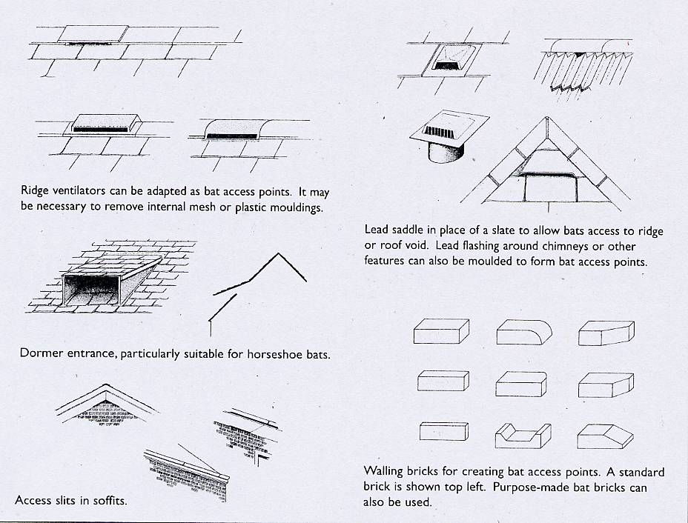

Figure 1. Bat access points

The simplest roost creation or enhancement technique is to provide or improve access to a structure that is already broadly suitable as a bat roost. This might include most modern, pitched roof spaces that are not intended for human occupation (as ‘loft conversions’) or regular storage use, but are adjacent or reasonably close to a likely commuting corridor as described in 4.1 above. Some non-residential stone or brick-built cavity structures, for example canal and river bridges or perhaps monuments, could also be imaginatively adapted in this way (see references 3 & 6).

The species of bats most likely to use roof spaces require only very narrow and unobtrusive access points (see Figure 1). Ridge ventilation tiles can provide the required gap, although any internal mesh or moulding may have to be removed. Protective lead flashing around chimneys or other features can be slightly raised and moulded to form bat access points. A slight gap between the exterior wall and an eaves soffit may provide access into the soffit box or over the top of the wall and into the roof space itself. This is especially useful if located towards the gable apex of end walls. Bats also regularly roost behind exterior cladding on buildings, such as hanging tiles, shingles and weather or barge boarding, especially if this has a southerly aspect. Providing small gaps between the individual overlapping components of this will enhance access opportunities.

Bricks may be specially shaped or crafted to provide small gaps for access into cavity spaces. Purpose-cast bricks featuring bat-sized slots and recesses are also available (see the ‘Norfolk Bat Brick’ www.norfolk-bat-group.org.uk/norf.html and ‘Bat Brick’ by Bioquip www.bioquip.net/acatalog/boxes_for_building.html). Lastly, care should be taken to avoid illuminating any new entrances with artificial light sources, such as security lights.

4.2.1 Bat boxes

In woodlands or parklands within preferred strategic situations (see above), and especially if these are managed as nature reserves, bat boxes are the most obvious form of supplementary roost provision for bats. Appropriate box designs can also be mounted on buildings both internally (within roof spaces or cellars provided there is sufficient access, for example) and on the exterior.

Although the standard Bat Conservation Trust (BCT) wooden box design (see right) is still one of the easiest and cheapest to construct, the German company Schwegler (see www.schwegler-natur.de/Fledermaus/index.htm) currently manufacture the widest range of pre-assembled boxes for European species, designed for various applications. These and other brands are marketed in the UK by several suppliers, including Alana Ecology Ltd and Jacobi Jayne Ltd (see http://www.alanaecology.com/acatalog/Bat_Boxes.html http://www.jacobijayne.co.uk/default_list.php?page=NSBX&type=BAT).

Boxes need to be mounted high enough on trees to prevent unscheduled disturbance, vandalism and theft. They should be located so as to provide a relatively clear approach that is free of overhanging vegetation, but also dark (away from any direct street lighting for example). They should be mounted in clusters of two or three, facing various directions (one of which should point due south). It has also been recently proved that bats use boxes externally painted or stained black more frequently than untreated boxes. For further suggestions on the optimal siting of boxes see the detailed case-study on Highgate Woods (Appendix 2.2). For an in-depth treatise on the comparative effectiveness of most currently available boxes, see reference 12 (Swift, 2004) available from the BCT website.

Several box designs are suitable for fitting to the interior of roof spaces, and their deployment would ideally accompany the enhancement of access opportunities as discussed above. What is in effect a large ‘box’ can actually be built to contain the area around a designed access point. A problem with providing roosting opportunities in new residential developments may be the future owners’ attitude towards bats. This ‘containment box’ approach may be a significant way around this problem (see Figure 2). Soffit boxes and some types of rooftop venting structures might be suitably adapted to offer further contained roost opportunities.

An important feature of most summer roosts established in buildings is their high thermal absorption and retention, and the latest development in the design of bat boxes is to incorporate an electric heat source within a separate side chamber. This may be powered from the mains or via a solar panel. Heated box designs are currently being trialled in Scotland and further information is available in references 12 & 13. On the same principle, a roof-space containment box might be imaginatively located where hot water ducts or pipes act as the external heat source.

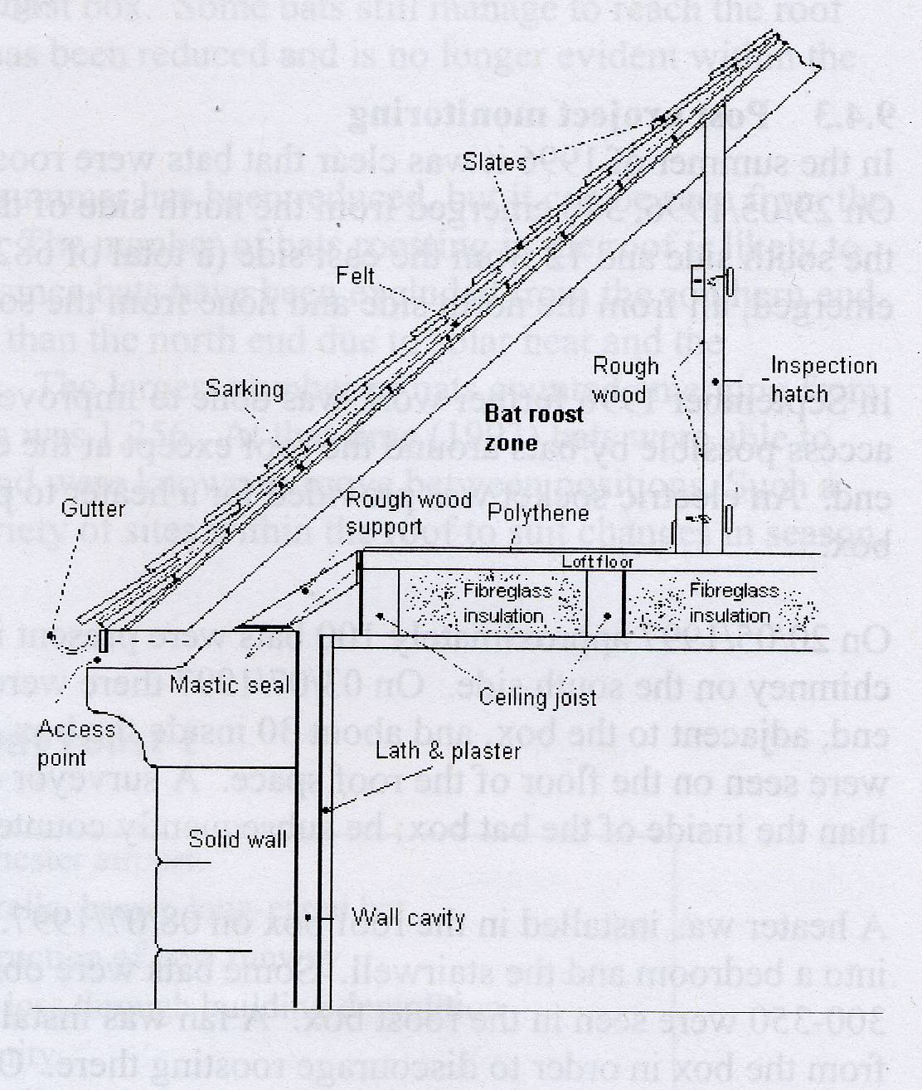
Figure 2. A bat box built into a residential house

4.2.2 Bat houses and lofts

The main objective when constructing a dedicated bat house or loft is to provide the widest possible range of roosting opportunities and thermal conditions in one self-contained building. A careful design could offer ideal maternity conditions in the roof and for hibernation in the chamber(s) below, for example. This is a new field and experimentation to achieve standards for recommendation is ongoing. Although any building is likely to be tailored to the particular circumstances, the following features would ideally be incorporated into the overall
design:

The building should have a footprint of at least 5x4 metres, and a minimum height of 5 metres (including a 2m roof-depth); the roof should pitch at around 42°, and one side should face south (a more complicated variation might include a cross-gabled roof – see Figure 3); the roof should be covered in a dark-coloured material (for example slates); stone-built walls (incorporating cavity boxes and, of course, access gaps) will promote thermal stability in winter, and both these and the gable ends of the roof should be clad with tiles or rough-sawn overlapped boarding; further cladding, tiles and even boxes could be mounted to the interior wall surfaces; external lighting is to be avoided. The future security of the building should be well planned, as it is likely to be a target for vandals and arsonists. Lastly, it should not be overlooked that such a building is likely to require planning permission. For further information on specifications for bat houses and lofts, see the case-studies in the recent publication Bat mitigation guidelines (English Nature, 2004), and the American website www.batcon.org/bhra/index.html.

4.2.3 Hibernacula Figure 3. A UK-type bat house

Non-residential built structures that may be considered broadly suitable as bat hibernacula include disused tunnels, icehouses and pillboxes, as well as obsolete industrial buildings, such as pump-houses, boiler and other plant rooms etc. These can all be enhanced to improve their potential with minimal effort. Most importantly, access must be strictly controlled by installing a lockable, grilled door. If considered necessary, interior temperatures (and humidity) can be stabilised and adjusted by altering the through-flow of air. Blocking unnecessary entry-points, or building a hanging wall to narrow the entrance(s) of the structure, may achieve this. The interior surfaces can be hung with tiles, boards, ‘bat-bricks’ and boxes to present the widest range of sheltering opportunities within. Lastly, a thermal data-logger is a useful tool to remotely monitor the performance of the hibernaculum. For further reading on the theory, enhancement, design and construction of artificial hibernacula, see Chapter 11 (pages 111-125) of the Bat Worker’s Manual (JNCC, 2004).

- References and further reading

1) Bat Conservation International (1993). The Bat House Builder’s Handbook (see
http://www.batcon.org/bhra/index.html; http://www.owls-etc.com/bathouse.htm)
2) Bat Conservation Trust (1993). Bat boxes – how to make them and where to put them
3) COBIB/EN (1997). The conservation of bats in bridges project – a report on the survey and conservation of bat roosts in Cumbria
4) English Nature (2004). Bat mitigation guidelines
5) Greenaway F R (1990). Converting a pillbox. Surrey Wildlife Trust
6) HIGHWAYS AGENCY (1999). Design Manual for Roads and Bridges, Vol 10, Environmental Design. Nature Conservation Management in Relation to Bats. HMSO
7) JNCC (2004). Bat Workers Manual (3rd Edition)
8) National Trust (2001). Wildlife and Buildings; technical guidance for architects, builders, building managers and others
9) Royal Society for the Protection of Birds (2002). Make a Bat box
10) Scottish Natural Heritage (1996). The design and construction of bat boxes in houses
11) Stebbings B & Walsh S (1985). Bat Boxes. FFPS
12) Swift S M (2004). Bat boxes: survey of types available and their efficacy as alternative roosts, and further progress on the development of heated bat houses. BCT/Mammals Trust UK
13) Swift S M (2004). The use of heated bat houses as alternative roosts for excluded nursery colonies. Report to MTUK, SNH, EN, CCW, & DoENI

6. Contacts

Expert advice:
Bat Conservation Trust – tel. 020 7627 2629, or Helpline 0845 1300 228. Email. enquiries@bats.org.uk. Web: www.bats.org.uk
London Bat Group – enquiries@londonbats.org.uk. Web: www.londonbats.org.uk Species Action Plan enquiries: mike.waite@london.gov.uk
English Nature London Office – tel. 020 7340 4870
Greater London Authority (Biodiversity team) – 020 7983 4320
Institute of Ecology and Environmental Management – www.ieem.org

Acknowledgements

Figure 1; from Bat Workers Manual (3rd Edition) JNCC
Figure 2; from The design and construction of bat boxes in houses Scottish Natural Heritage

Appendix 1. Bat roost creation projects – Greater London

Borough | Site | type | year of creation | Manager | notes on history, species involved etc. | Grid ref.
Barking & Dagenham | Beam Valley Pill-box | Hibernaculum enhancements | 2003 | LA | Thames Gateway SRB funding; Pillbox conversion (grilled)
Barnet | Oak Hill Woods Nature Reserve | Bat boxes (x85+) | 1985- | LWT/LA | Local Nature Reserve  - Pipistrelles, Noctules & Long-eared bats | TQ279951
Brent | Welsh Harp Ecology Centre | Artificial hibernaculum | 1986 | LA | Vandalised; not used | TQ209872
Bromley | Blacklands denehole | Hibernaculum enhancements | 2001-2 | LA | Local Nature Reserve/part SSSI  Boards erected; Grilled; x75 bat boxes  - Daubenton’s bats, Natterer’s bats, Long-eared bats | TQ439631
Bromley | High Elms Icehouse | Hibernaculum enhancements | 1999-01 | LA | Local Nature Reserve  Boards erected  - Long-eared bats, Daubenton’s bats, Natterer’s bats | TQ445635
Bromley | Pratts Bottom | Hibernaculum enhancements | 1988-00 | Private | Grilled  Additional entrance grilled  - Daubenton’s bats, Natterer’s bats Whiskered/Brandt’s bats, Long-eared bats | TQ461623
Bromley | Petts Wood | Bat boxes |  | National Trust |  | TQ450690
Bromley | Kelsey Park, Beckenham | Bat boxes (x10) | 2002 | LA | - Leisler’s 9/04, Pipistrelle bats | TQ3768/  3769
Bromley | Crystal Palace Park | Bat boxes (x11) | 1999 | LA | - Pipistrelle bats | TQ3470/  3471
Bromley | Well Wood | Bat boxes (x11) | 1999-01 | LA | - Pipistrelle bats | TQ3964
Bromley | Jubilee Country Park | Bat boxes (x11) | 2002-4 | LA | Local Nature Reserve  (inc. 1 hibernation box)  - Pipistrelle bats | TQ4368/  4367
Bromley | Scadbury Park | Bat box (x1) | 2004 | LA | Local Nature Reserve  (Hibernation box) | TQ4569
Bromley | High Elms Country Park | Bat boxes (x22) | 1990s-2004 | LA | Local Nature Reserve/part SSSI  (inc. 2 hibernation boxes)  - Pipistrelle bats | TQ4462/  4463
Bexley | Lesnes Abbey Woods  (Abbey Wood) | Bat boxes (x20) | 2001 | LA |  | TQ475782
Bexley | Riverway (R. Shuttle) | Bat boxes | 2001 | LA
Bexley | Crossness Nature Reserve | Artificial hibernaculum | 2002 | Thames Water |  | TQ4980
Bexley | Chalk Wood denehole | Hibernaculum enhancements | 1982-2001 | LA | Grilled  - Natterer’s bats, Long-eared bats | TQ493706
Camden | Hampstead Heath Woods | Bat boxes (x40) |  | CofL
Camden | Hampstead Heath Pergola | Hibernaculum enhancements | 2003 | CofL | - Long-eared bats, Natterer’s bat
Camden | Viaduct Pond bridge | Poss. hibernaculum enhancements |  | CofL
Camden | Waterlow Park | Bat boxes |  | LA |  | TQ286871
Croydon | Addington Hills | Bat boxes |  | LA/TfL | Mitigation for Tramlink | TQ3564
Croydon | South Norwood Lake | Bat boxes (x5) |  | LA |  | TQ340693
Croydon | Kenley Common air-raid shelter | Hibernaculum enhancements | 1995 | CofL | Secure doors fitted  Roosting enhancements – not used
Enfield | New River | Bat boxes |  | Thames Water?
Greenwich | Greenwich Eco-park | Bat boxes | 2000 | English Partnerships |  | TQ400794
Hammersmith & Fulham | Kensal Green Cemetery | Bat boxes |  | LA/LWT | Potential for catacombs to be enhanced | TQ233825
Haringey | Highgate tube station tunnel | Hibernaculum/swarming enhancements | 2001-2 | LUL/CofL | - Long-eared bats, Natterer’s bats, Daubenton’s bats | TQ285883
Haringey | Highgate Wood | Bat boxes (x31) | 1993- | CofL | (inc. 2 Hibernation boxes)  - Noctule, Leisler’s, Pipistrelles | TQ285885
Haringey | Queen’s Wood | Bat boxes (x4) | 2002 | LA |  | TQ288885
Haringey | Tottenham Marshes | Bat boxes (x18+) | 2002 | LVRPA/CofL |  | TQ351905
Haringey | Ferry Lane Estate | Bat boxes (x3+) |  | FOE
Hillingdon | Court Park, Uxbridge | Tree roost preservation | 2002 | LA/EN | Important Noctule roost retained  (mitigation) | TQ073840
Hounslow | Bedfont Lakes Country Park | Bat boxes (x30+) | 1993-03 | LA/Herts&Middx BG | - Nathusius’, common, soprano pipistrelles | TQ081726
Hounslow | Cavalry Tunnel Feltham Marshalling yards | Artificial hibernaculum | 2001 | Network Rail/LA
Kensington & Chelsea | Holland Park | Bat boxes | 2003 | LA/LBG |  | TQ2479
Kensington & Chelsea | Natural History Museum Wildlife Garden | Bat boxes | 2003 | NHM/LBG |  | TQ266792
Kingston | Canbury Gardens | Roosting “turrets” | 1990s | Private | Mitigation for former power station demolition | TQ178698
Kingston | Jubilee Wood Pill-box | Hibernaculum enhancements |  | LA/MVMP | LNR (Mole Valley) | TQ172617
Merton | Fishpond Wood | Bat boxes | 2005 | LWT | LNR | TQ217707
Redbridge | Hainault Country Park | Bat boxes | 2003 | LA/Forestry Commission | On island in lake | TQ474927
Redbridge | Hainault Lodge Nature Reserve | Hibernaculum creation | 2003 | LA/Forestry Commission | Conversion of old boiler shed | TQ475920
Redbridge | Valentine’s Park | Bat boxes | 2003/4 | Valentine’s Park Conservationists | In trees behind canal | TQ436449
Richmond | Lonsdale Rd. Reservoir (Leg-o’-Mutton) | Bat boxes (x12) | 1998 | LA | LNR | TQ217773
Richmond | Venison House, Holly Lodge, Richmond Park | Bat-bricks (x8) | 2003 | RPA | in SSSI/NNR | TQ195740
Richmond | Kempton Waterworks | Bat boxes |  | Thames Water
Richmond | London Wetlands Centre | Bat boxes (x14) | 1998 | WWT/LBG | SSSI | TQ228770
Richmond | London Wetlands Centre | Roof structures in main building
Southwark | Dulwich Park | Batboxes (x3)
Southwark | Sydenham Hill Wood | Hibernaculum enhancements |  | LWT/LA | LNR. Potential to enhance rail tunnel | TQ344727
Southwark | Sydenham Hill Wood | Bat boxes (x12) |  | LWT/LA | LNR | TQ344727
Westminster | London Zoo | Bat boxes | 2003 | ZSL |  | TQ280836
= 20 boroughs |  |  |  |  | Total projects (since 2000) = 27

Key: LA = Local Authority; LWT = London Wildlife Trust; CofL = Corporation of London; WWT = Wildfowl & Wetlands Trust; LBG = London Bat Group;

ZSL = Zoological Society of London; MVMP = Mole Valley Management Project; LVRPA = Lea Valley Regional Park Authority; RPA = Royal Parks Agency; LU = London Underground; FOE = Friends of the Earth; LNR = Local Nature Reserve; SSSI = Site of Special Scientific Interest
Appendix 2. Case-studies

1 Highgate Woods bat boxes

Highgate Wood is a 28.3 ha ancient Oak-Hornbeam woodland owned and managed by the Corporation of London. The wood is integral to an important Green Corridor serving inner northeast London. It is linked on one boundary to another ancient woodland (Queens Wood) which is connected to extensive playing fields, and on a further side to a disused railway line.

31 bat boxes have been erected since 1993. Bat boxes are carefully positioned adjacent to woodland edges and clearings, along paths and rides (ie. on flight-lines), and on mature trees that already feature natural roost holes. A licensed bat worker monitors all boxes for use each autumn.

The majority of boxes are based on the standard BCT design. There are also two Tanglewood Wedge boxes, two Greenaway boxes and five open-bottomed boxes based on a scaled-down American design. Most boxes have been painted black with Ronseal Fencelife (water-soluble and non-harmful to wildlife). The number, range of designs and diligent monitoring of bat boxes at Highgate Woods has provided valuable experience to assist the planning of future projects.

About 50% of bat boxes have been used at the site, as well as one bird nest-box designed for Treecreepers. Four species have been recorded, including Common pipistrelle, Soprano pipistrelle, Noctule and Leisler’s bat. Occupation is highest during autumn when bats form ‘harem roosts’ involving a male and one or more females. Every type of box has been occupied, although of the five most regularly used, four are standard BCT boxes. Two of these are made from timber resulting in a slightly narrower, more shallow design, and all have smaller entrance slits than recommended (10-15mm as opposed to 15-20mm wide). The varied design and materials used in the Highgate boxes appears to have paid off, in that these now offer a range of conditions which are suitable for different species at various stages of the year. Orientation has been less conclusive, with positioning to receive maximum shelter appearing more important than aspect. A well-fitted roof to exclude wind and rain is also essential.

The later-designed boxes have features to deter use by competitors such as birds and squirrels, and most notably, have been used more quickly post-deployment than the standard boxes. Two of the most regularly used boxes are located close to trees containing natural roosts, including old woodpecker holes. Bat box use also appears to be concentrated in parts of the wood where there is a history of wind damage, perhaps as bats actively seek trees with splits and fungal decay for natural roosts. Two such roosts have been lost during the monitoring period due to collapse, suggesting that artificial roosts (boxes in this case) may play an important role as relatively stable roosts within a dynamic environment. Most recently (2003), two large Schwegler hibernation boxes have been added to the suite of artificial roost opportunities on offer to bats at Highgate Woods.

2 Highgate railway tunnels

In 1996 London Underground commissioned an ecological survey of two parallel disused railway tunnels close to Highgate tube station. This identified the tunnels’ potential importance as a hibernaculum for Natterer’s and Brown Long-eared bats (a single individual of each species was found). In 1999, an experienced bat worker was engaged by LU to carry out a detailed bat survey. Using remote sound recording equipment and later, mist nets for bat capture, this survey identified the additional importance of the tunnels as an autumn swarming site, particularly for Natterer’s bats. In his final report, the bat worker recommended that one tunnel be left as it was, while the other be modified to create a more stable environment favourable for hibernating bats. Therefore a hanging wall was erected at one end to adjust the through-flow of air. He also suggested that further roosting crevices be created on the tunnel walls.

These recommendations were eventually implemented in 2001. Survey during the interim period found further evidence of the tunnels’ importance as a roost for Long-eared bats. By October 2001, the enhancement works were almost complete, with 46 bat bricks, 12 concrete bat boxes and the hanging wall all in place. An adit joining the two tunnels was also later restored. Subsequent surveys of the tunnels have continued to prove the value of the enhancements. In December 2002 a single Natterer’s bat was found in one of the bat bricks close to the entrance. In February 2003 Natterer’s bats were found in both tunnels. Most recently Daubenton’s bats have begun to use the site. Careful local environmental monitoring has shown that the hanging wall has successfully stabilised the interior temperature.

London Biodiversity Partnership, The Action: Volume 2 of the London Biodiversity Action Plan, 2001
London Biodiversity Partnership, Action for Biodiversity - Meeting the Cost, 2003
London Biodiversity Partnership, Built Environment Generic Action Plan, 2004

