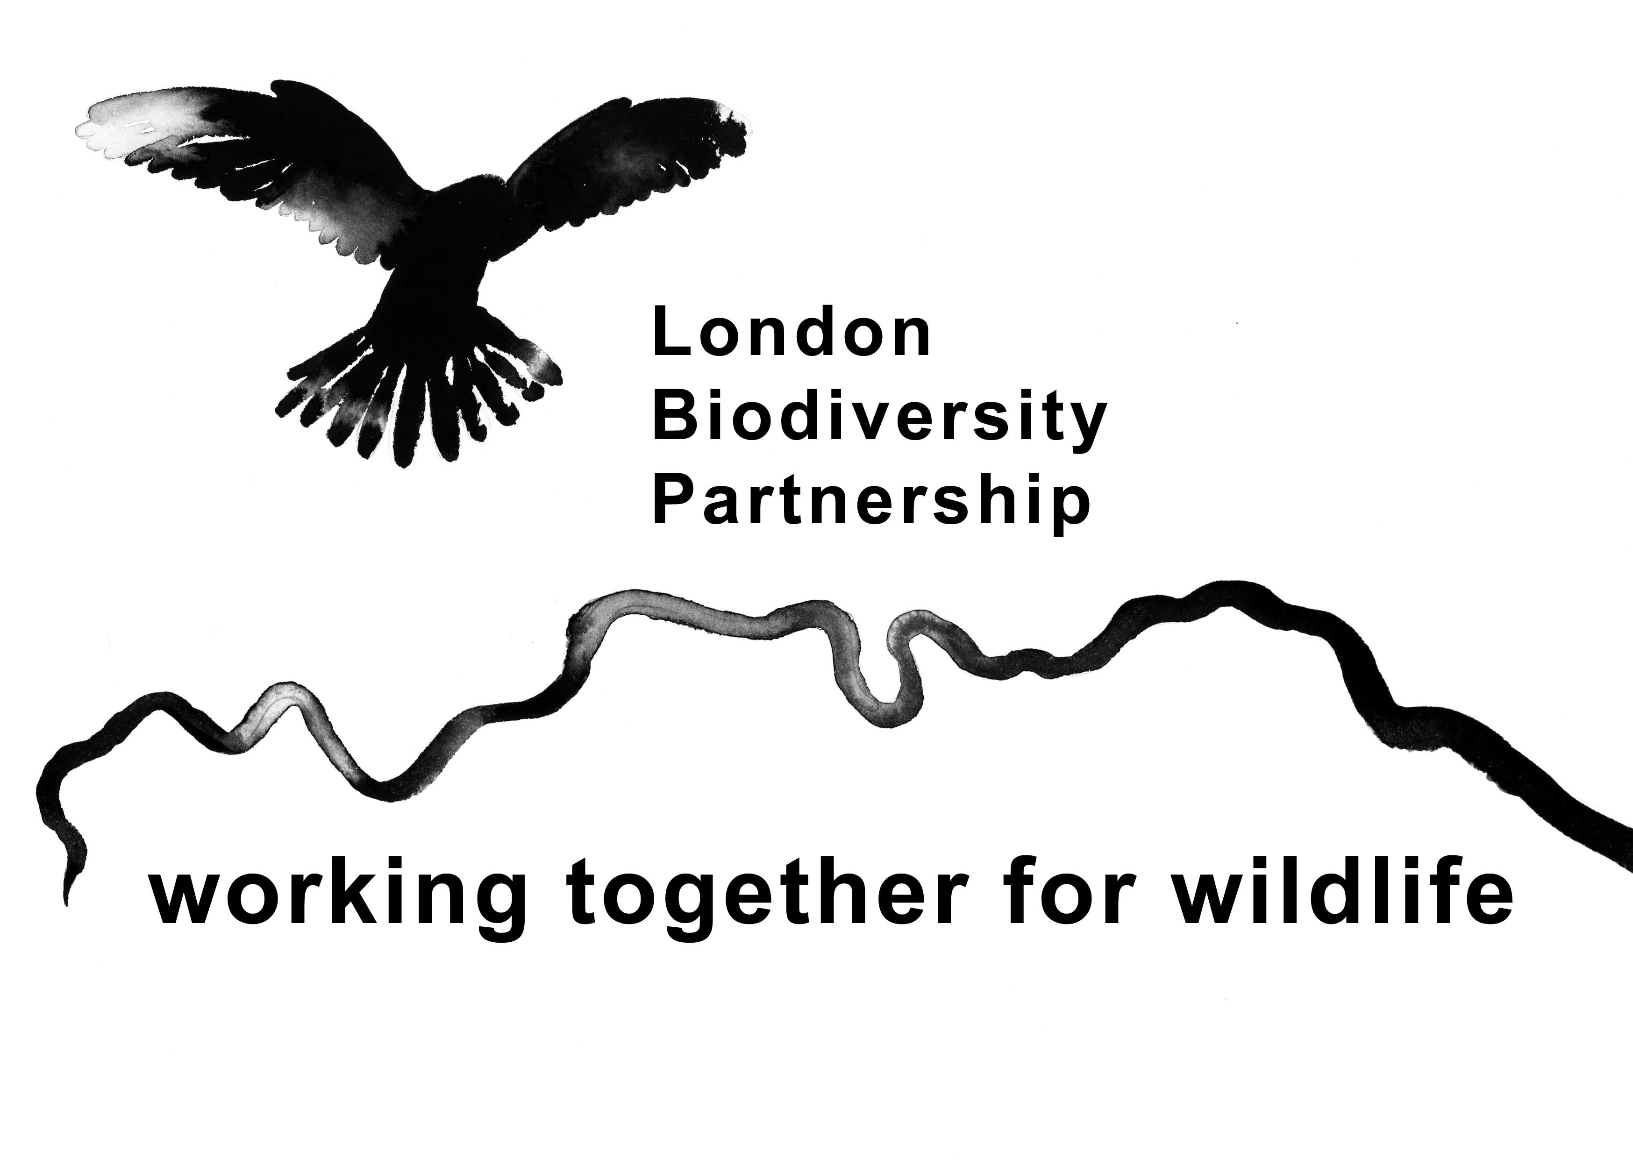
Business and Biodiversity
London Biodiversity Partnerships
27th July 2004 at London Ecology Centre

Introduction and Expectation

- Gain understanding of how to engage business in biodiversity action
- Share experiences of engaging companies
- Identify benefits and challenges of working together
- Explore ways in which to engage with business

Why Local Biodiversity Action Plans (LBAPs) and business should work together

The Business Perspective | The Local Biodiversity Partnerships (LBPs) Perspective
Raise the profile of the business with customers. Publicity | Access to money
Improve employee retention | Access to skills, labour and equipment
Employee development/ team building | Networks – power to reach different people and access larger audience
Attract funding (Attractive to investors) | Access to business landholdings which could be managed for biodiversity
Product development | Domino effect – businesses talk to businesses and get access to other businesses.
Enhance scoring on environmental audits | Promote the greening of business buildings.
Improve relationship with local communities. Gain licence to operate both legal and with local communities. | Influence procurement and supply chain and other environmental policy.

Specific Opportunities/Actions for LBPs
- Working with the Corporation of London. There are lots of businesses that want to work on biodiversity projects and there are not enough projects. LBPs could start to use the Corporation as a way of gaining contact with willing business partners.
- Use volunteers from businesses to help out with developing LBAP engagement with business. Retired business men and women maybe keen on working on a voluntary part time basis for LBPs
- Approach business forums and networks to get access to smaller businesses. Can present to Chambers of Commerce about biodiversity.
- Think outside the box. Don’t necessarily approach businesses directly. Talk to investors and auditors to gain leverage over businesses.

Barriers
LBPs Working with Businesses
- Don’t know who to contact in the businesses. Difficult to get contact with the right people in the business. Need to get past the “gate-keeper”
- Language barriers. Need to talk the language of business.
- Difficult to know how to involve businesses in the development of an action plan.
- Lack or resources within LBPs to spend time contacting businesses.
- Do not have the capacity to contact lots of businesses. Just go for the easy wins. Can be difficult to prioritise.
- Internal politics of companies can be a barrier to working together. Need persistence. Approach other people/departments if first contact doesn’t work out.
- Volunteers are usually available after working hours or at weekends and to engage with businesses they need to be available during working hours.
- Danger of being used by company for “Greenwash”
- Incorporating sufficient flexibility in action plans so businesses can be involved in developing ideas.
- Difficult to get big companies to appreciate value of local project.

Businesses working with LBPs
- Too much science. Different languages – ecology v business
- Difficult to know who to contact in a biodiversity partnership.
- The is a lack of a business approach in LBPs
- Nature is not neat and tidy and does not follow business timetables.
- Lack of time to commit to working with LBPs

London LBAPs work to date with business – some comments
- (See Appendix 1 for details)
- Retailers – not much contact. In London they are distant from their land holdings and it is difficult to have activities on the ground with them.
- No engagement with oil and gas sectors. Why?
- LBPs could prioritise businesses to target by sector. Most contact has been opportunistic and not strategic.

Other ideas raised
1. LBPs need to be clear about what they want from businesses.
- To get money to run projects not directly related to the business
- Work with and help the business manage biodiversity projects on business sites.
- Influence the business policy and strategy to improve biodiversity management – this could then lead onto further work with LBPs.

2. Need to have good communications with businesses once a relationship has started. Don’t just grab money and run – report back on the benefits which the money/working with the LBP is bringing to them, the environment and society.

3. Need to develop a “Power Pitch.” A general way of approaching businesses. LBP needs to be clear in their pitch what they want e.g. just money or deeper engagement.

4. Be persistent! If the first person that you contact is not interested contact someone else. Ideally find someone in the business with an interest in biodiversity.
Appendix 1
London’s Local Biodiversity Partnerships and Regional BAP - working with businesses
 | Industry & Manufact. | Utilities | Quarrying and extractives | Construction | Retail and Food &Drug | Financial  Services | Other
Large Companies (500 plus employees) | GSK x2 | London underground  Metronet  Thames Water x3  Rail Track  Electric Companies | Lafarge | Laing Homes  Crest Nicholson  Mouchel  Developers | Sainsbury  Waitrose | HSBC x4  Barclays x 2  Deutsche Bank | Canary Wharf  Reed Elsevier
Medium Companies  (60 - 100 employees) | SARNA  Bauder  Alumage |  |  | Developers  ATD |  |  | British Waterways x2  Grovesnor estates
Small Companies (60 or Less employees) |  |  | Westminster Dredging | Developers  Small architects |  |  | Printing firm x2  Garden centre  Farms x2  Local schools x2

Activities conducted with Businesses

GSK | Transferred some land which a LBP managed as an educational Nature reserve.  Support Environmental Awards in Bromley
SARNA | Publicising biodiversity Green Roofs
Bauder | Publicising biodiversity Green Roofs
Alumage | Promoting Green roofs
London underground | Provide expertise on Project Board of the Regional BAP. Engage with specific projects.
Metronet | Management of underground rail verges.
Thames Water | Partner on Sand Martin Species Action Plan
Thames Water | Provide expertise on Regional BAP Project Board. Founder of water vole SAP. Help with Habitat audits etc..
Rail Track | Founding member of Regional Partnership. Sponsor the Regional BAP. The Partnership contribute expertise to company BAP.
Lafarge | Potential conversion of quarry to wetland nature reserve.
Westminster Dredging | Use of extracted material to create pools good for birds.
Crest Nicholson | Section 106 agreement
Laing Homes | Transfer of land to Bromley under section 106
Mouchel | Tree planting
Sainsburys | Provide food for an event
Waitrose | Resources for a public event
Various developers | Planning applications (section 106 agreements)
ATD | Sources of aggregates for green roofs
Architects | Use green roofs in their design
HSBC | Funded public event. Employee volunteering (part of Earthwatch fellowship programme.)  Provide technical advice and money for bird/reed bed platforms on local nature reserve.
Barclays | Biodiversity roof in new building. Money donations for tools.
Deutsche Bank | Provide volunteers
Reeds Elsevier | Publish documents on reed bed site creation and employee participation
Canary Wharf | Set up biodiversity Business Plan
British Waterways | Input to national biodiversity strategy. Chair Regional BAP working group. Member of Partnership’s project board. Lead for Regional BAP canal HAP. Fund water vole SAP officer
Greenprint | Subsidised printing of Regional BAP Publications
Grosvenor Estates | Participation in Regional Park HAP and donate to survey.
Garden centre | Promote wildlife garden
Farms | Adoption of Countryside Stewardship scheme
Schools | Transfer of land permit biodiversity improvements.

Appendix 2
Business Case Exercise

NUT Bank

Background and task
A multi-national bank based in the City offering a full range of financial services including personal and commercial financial services, trade finance, funds management, electronic banking and investment advisor. NUT Bank’s corporate headquarters are located in London, along with 12 of its banking outlets.

With more than 5,000 offices world wide, the company recognises its environmental responsibility but to date has not grappled with the topic of biodiversity.

Prepare a 5 minute presentation to board of directors to convince them that biodiversity is an important issue which NUT bank should be addressing. Consider the following two points:

- what are their biodiversity impacts?
- why these impacts pose a risk for them

Presentation
Why are they at risk?
1. Law and legislation
- Voluntary reporting now
- Mandatory reporting by 2005 (OFR)
2. Reporting and image
- Investing in damaging projects affects reputation
- Opportunities for competitiveness from green reputation
3. Stakeholder relationships
- Customers, employers, investors and neighbourhoods. Partnerships are a mechanism for engagement with stakeholders, enhance image and local environment.
4. Employee motivation and productivity
- Enhance local environment
- Retention of staff
- Higher quality work outputs
- Team building
- Show care for local community top to bottom links.
5. Attracting investors
- Improved image by association with real green projects.
- Ethical investment niche, enhanced competitiveness. (Green £’s)
6. Sustainable development and CSR
- Biodiversity – a key component of SD and CSR
- Triple bottom line includes engagement with biodiversity.

Example
Greenybank
- Greened its property
- Reduced energy and water bills
- Improved employee productivity by local environment enhancement and participation in healthy conservation tasks
- Increased market share by enhancing its green image
- Improved profitability by 80%!!
- Used LBP
- LBP was key in helping them drive these improvements

Big-dig Quarry

Background and task
Big-Dig Quarry is a leading international supplier of aggregates, concrete and cement used predominately in the construction industry. It employs over 10,000 people across Europe through more than 500 sites which are responsible for materials extraction, processing and distribution. The company operates in 15 locations across the UK and has its headquarters in London where corporate policy is developed and set.

The company recognises that its licence to operate depends on its ability to run its businesses in a sustainable manner and that concerns, such as climate change and biodiversity, must be proactively managed alongside local, day-to-day matters like legal compliance. With operations in different countries and communities the organisation understands the importance of working with different stakeholders in order to fulfil its mission.

Prepare a 5 minute presentation to the board of directors to convince them that biodiversity is an important part of environmental management which Simple Software can help to address. Consider the following two points:

- who are their main stakeholders?
- how can they be involved in the biodiversity process?

Presentation
Biodiversity – it is already there!
They have several species on their sites – Sand Martins, Lapwings, Brown hare, water voles etc.
Benefits for Big- Dig of dealing with biodiversity
- Publicity
- Building community relationships
- Show of Corporate responsibility
- Sustainability
Company Stakeholders
- User groups, local interest groups
- Environmental organisations
- Hunters(?)
- Staff of company
- Landowners (Quarry land and surrounding)
- Local residents
- Customers of company
- Local authorities
- National governments
- Utilities
- Company shareholders
Involvement of stakeholders
- Practical survey or management work
- Writing and implementing BAP’s
- Ideas for future site use
- Management planning
- Open days
- Amending the stakeholder interface
- Meetings
- Positive relationship with environment and related stakeholders

